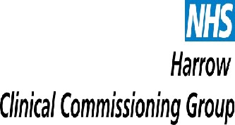
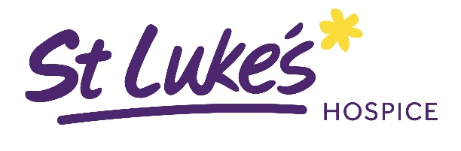

St Luke’s Palliative Helpline (Pall 24)
The pall 24 service aims to improve the patient experience by providing better coordinated care for those in the last year of life and facilitate choice over the place of care and death. The service will assist in preventing avoidable admissions and delayed discharge from the Hospital. Telephone advice and support is provided 24 hours a day, 7 days a week by calling 03000 200 224 and a rapid response visiting team available 7.30am – 9pm, 7 days a week.

ESSENTIAL REFERRAL CRITERIA:
- Is the patient identified as being in last 12 months of life? ☐
- Is the patient over 18 years of age? ☐
- Is the patient permanently registered with a Harrow GP and living within one mile of the borough border? ☐
- Has the patient given consent to share their information via UCC? ☐
- Has the Patient given consent to share their information with other health care professionals? * ☐
- Has patient/family/referrer is aware and have consented to refer to palliative helpline? ☐

If you have ticked all these boxes please complete the Pan London Palliative Care referral form and send to: Email: nhsnwl.palliativehelpline@nhs.net
If the referral is for Harrow Community Specialist Team, please email to: clcht.harrowpalliativecare@nhs.net
If the referral is for Brent Community Specialist Team, please email to: LNWH-tr.referralsstlukes@nhs.net
IMPORTANT
Please provide us with all clinical information concerning your patient, including DNAR forms if in place. We can then legally share details *(See above) with other healthcare professionals. Please send us any recent letter or discharge summary or assessment.
Patient name: Patient DOB:
Referrer’s signature:

